Problem Set #5:

Power, GLMs, and Frequencies

(1) (5pts) You plan to test the effect of a protein-supplemented diet on growth of green iguanas. You will have two treatment groups: **one that receives a normal diet** of various plants and **another that receives a diet supplemented** with processed soy protein. You will use a **two-sample *t*-test** to evaluate the **effect of the supplemented diet**. Based on a small preliminary experiment, you think that average growth over the course of the experiment will be about 10 grams, with a standard deviation of 1.5g, and you’d like to be able to detect whether the difference between treatments is at least 1g.

1. How many replicates of each treatment will you need to have statistical power of 0.8 at α = 0.05? (Assume equal replication in the two treatments.)

After doing a power analyst test for a t-test, I found that we need at least **37 (n=6.27042) replicates per group** (no supplement vs. supplement diet).

1. Maintaining the same power (0.8) and α (0.05), how many replicates would you need to detect a difference of 3g between the two treatments?

After doing a power analyst test for a t-test, I found that we need at least **6 (n=5.089995) replicates per group**.

1. What if everything was the same as in (b), but you decided to set α at 0.01? How many replicates would you need?

After doing a power analyst test for a t-test, I found that we need at least 8 **(n=7.66057) replicates per group.**

1. What if instead you had only 20 iguanas total (10 for each treatment) to work with? What would the minimum detectable difference between treatments be with power 0.8, α = 0.05, and SD = 1.5?

After doing a power analyst test for a t-test, and working backward with d and the sd, I found that the **minimum detectable difference is 1.987.**

(2) (10 pts) Shannon was a former student in Casey terHorst’s lab who studied an invasive plant, *Medicago polymorpha*. She wants to know whether some genotypes of this plant are better able to invade disturbed areas. She conducts a field experiment in which she plants seedlings of eight different genotypes, planting five replicate seedlings of each genotype into each of two treatments: plots that have been disturbed, with vegetation removed and the soil raked to a depth of 2cm, and plots that were undisturbed, with vegetation and soil only altered as much as necessary to plant the seedlings. Some of the genotypes she uses were collected from the invasive range of this plant (North America, Asia, South America, Africa) and the others were collected from the native range of the plant, around the Mediterranean basin. After six months, Shannon measures the number of fruits produced by each plant. Use Shannon’s data, the file *Medicago.csv*, to fit a generalized linear mixed model and test whether the effects of disturbance and collection range (invasive/native) affect fruit production. Also test whether genotypes (a random effect, nested within collection range) produce different numbers of fruits.

Type III Anova on a glmm shows statistically significant effects of Disturbance (p<0.01), Range (p<0.05), and their interaction (p<0.001) on fruit production.

After fitting models with and without the random effect, ANOVA shows that genotype has a statistically significant (p<0.001) on fruit production numbers.

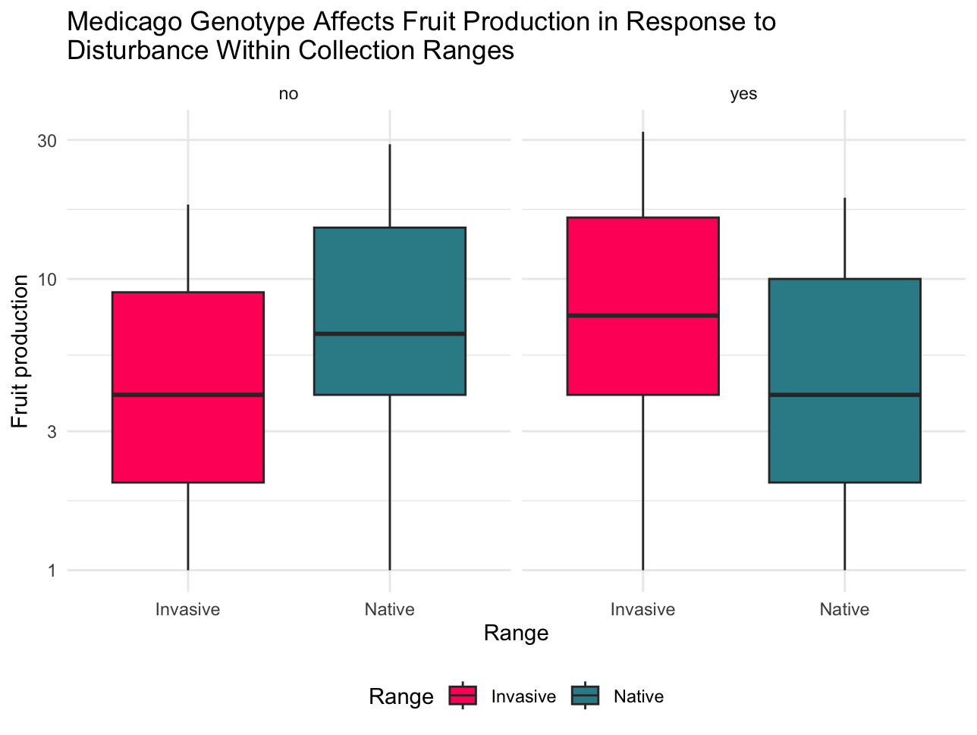

(3) (10 pts) Bridgette is a former student in Larry Allen’s lab who was interested in courtship behavior of black surfperch. She notices that large males seemed to receive more attention from females. To evaluate the effect of male size on probability of mating, she watches courtship behavior of 50 male surfperch with 50 females. She records the size of each male and whether it was successful (mated) or not after its courtship with the female. Analyze the data in the file *surfperch_mating.csv* to determine whether the likelihood of mating was related to male size. Write a brief statement of results and include a graph illustrating your regression.

(4) (5 pts) The sex ratio of non-sex-changing (gonochoristic) fishes is typically near 1:1. The local kelp forest fish, *Oxyjulis californica*, is a gonochore. Mark Steele’s lab collected 621 *O. californica* off the coast of Southern California in 2015. Of these, 371 were female and 250 were male. Use a Chi-square test to determine if this species adheres to the expectations of the general model for the sex ratio of gonochoristic fishes?

(5) (5 pts) You conduct an experiment to evaluate the mode of inheritance of the vestigial wing mutation in fruit flies. You obtain 161 wild type and 33 mutant offspring from a cross of the F1 generation. Do the data agree with a 3:1 Mendelian ratio? Does the answer depend on whether you do a Chi-square or *G* test?

(6) (5 pts) Marta is curious about how to cure a hangover. On the day after St. Patrick’s Day, she polls a large number of students across campus. First, she asks them if they’ve been drinking the night before, and only uses the responses of students who say yes. Then she asks two questions: (1) Did you drink water or Gatorade this morning? (2) Do you have a headache right now? The data are as follows:

|  | Water | Gatorade |
| --- | --- | --- |
| No Headache | 58 | 33 |
| Headache | 61 | 21 |

Analyze these data to determine if a student’s headache depends on what they drank.

(7) (10 pts) In the 2020 election, exit pollsters asked 22,457 voters of different race/ethnicities leaving the polls which candidate they voted for. The data for White, Black, and Latino participants are below. Use a log linear analysis to determine whether voting preference is dependent on sex or gender, or whether the effect of gender depends on race. Write a brief statement of your results.

|  | Voted for Biden | Voted for Trump |
| --- | --- | --- |
| White Men | 2588 | 5177 |
| White Women | 3907 | 5239 |
| Black Men | 1007 | 160 |
| Black Women | 1616 | 69 |
| Latino Men | 774 | 393 |
| Latina Women | 1017 | 510 |